1. Create database called “School”

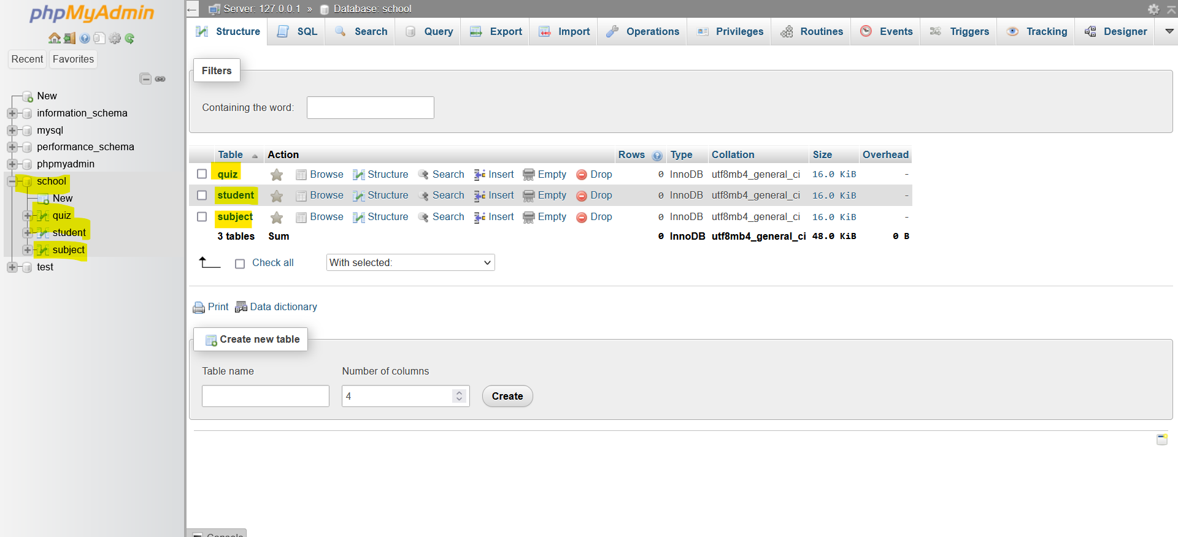

2. Create the following tables in your database a.student, his name, contact info, email and password. b.quiz or test, the type of the assessment, max score and its date. c. subject, name and the total grade.

#student table with data

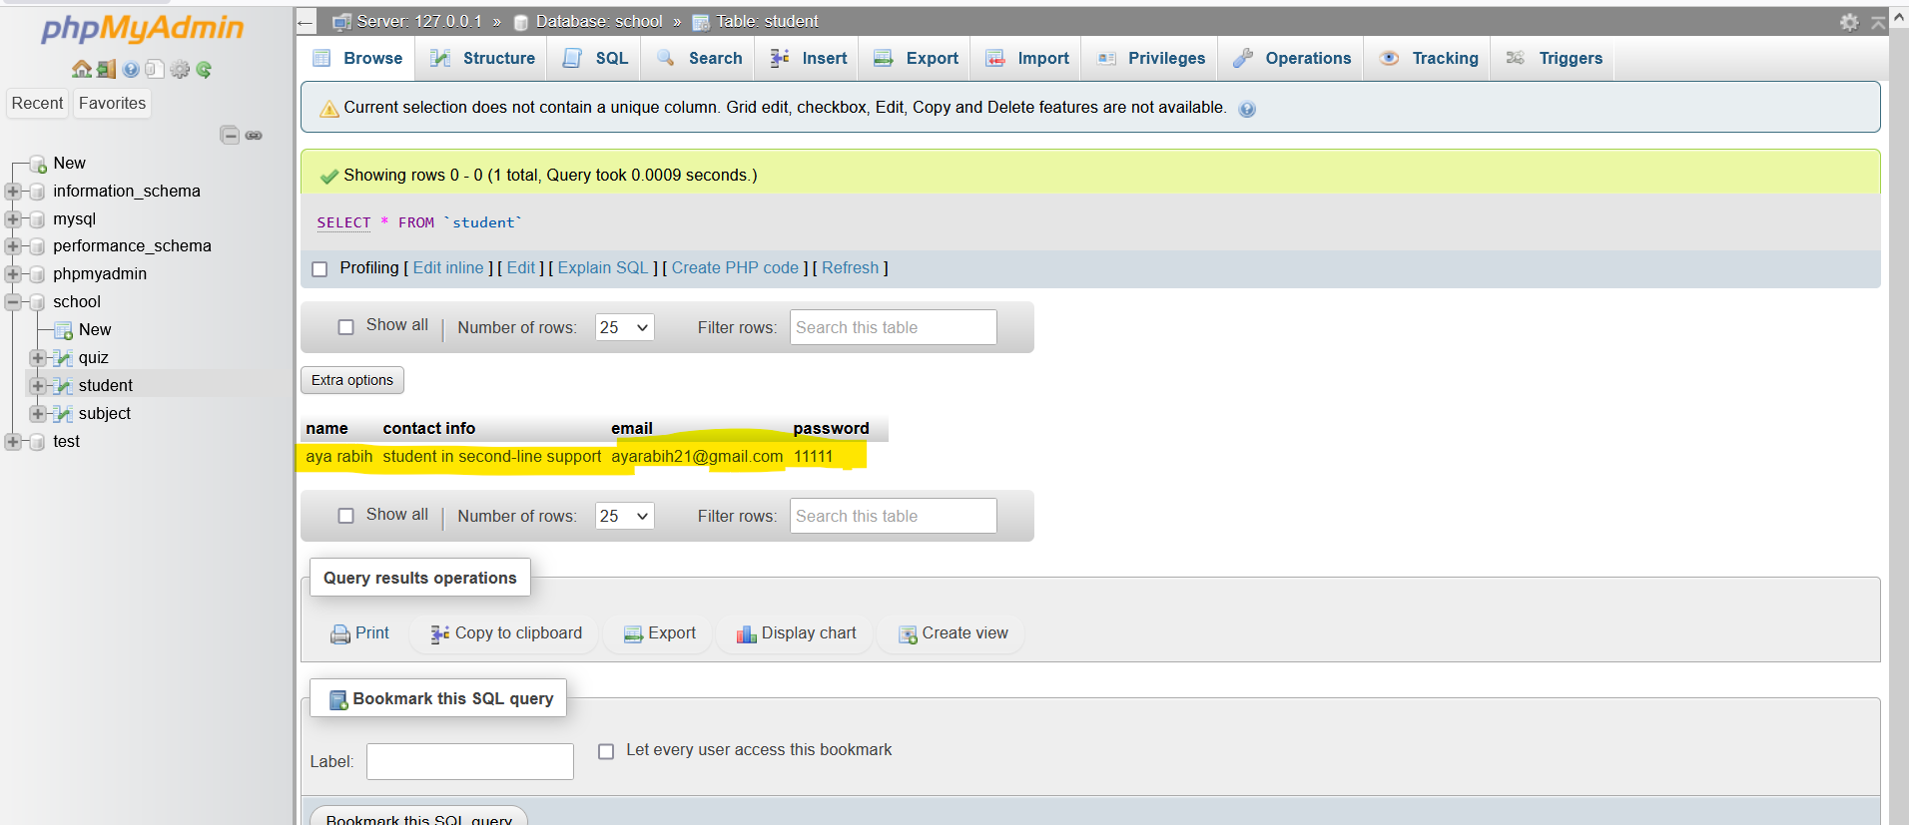

Score#

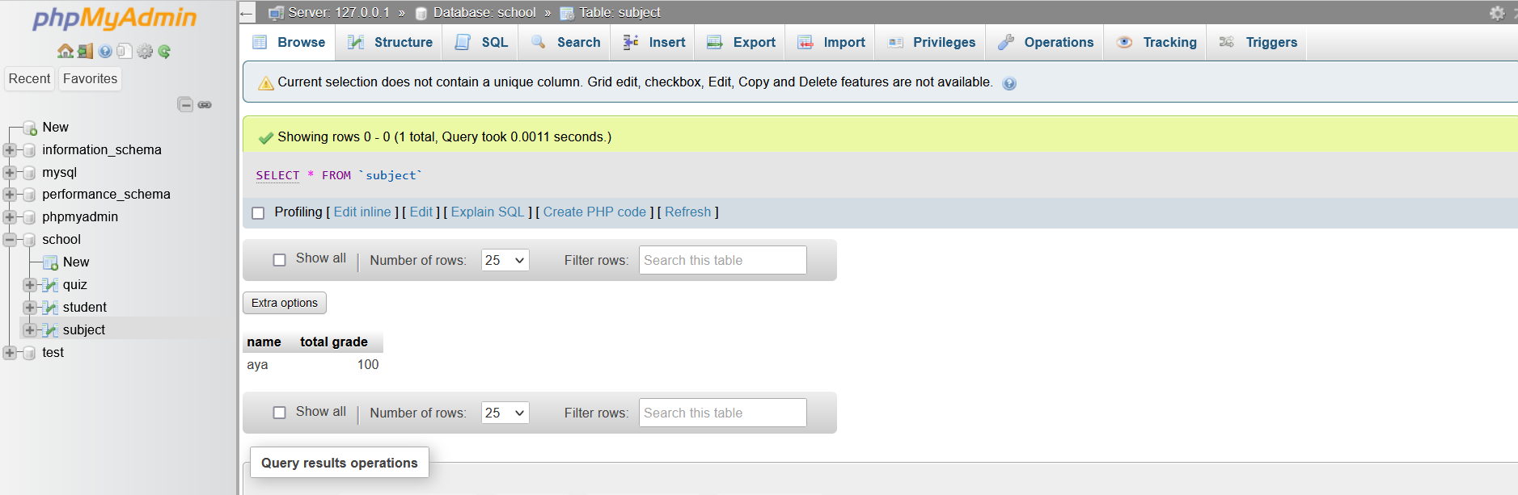

# quiz

